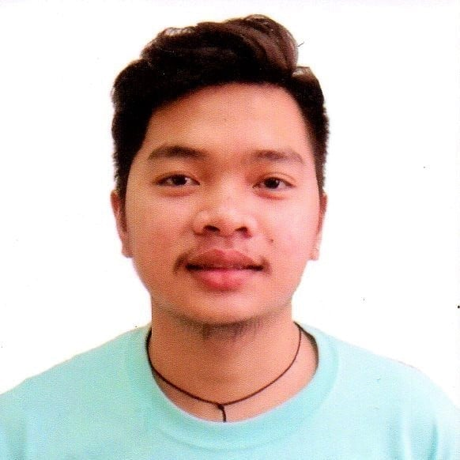
Mharck Stephen Pamintuan Magat
488. Cuyugan Street Del Pilar City of San Fernando, Pampanga
mharckmagat06@gmail.com
09063738539

Work Experience:

Triple K Printing Service
City of San Fernando, Pampanga
Encoder

November 2016 – May 2017

Special Program for Employment of Students
LGU - City of San Fernando, Pampanga
Spes Clerk
April 2020 - May 2020

RCJ Enterprise

City of San Fernando, Pampanga
Virtual Assistant

September 2021 – April 2021

Educational Attainment:
Tertiary Education - Don Honorio Ventura State University
Villa De Bacolor, Pampanga
2018 - Present

Secondary Education - Our Lady of Fatima University
Dela Paz Norte, City of San Fernando, Pampanga
2016 – 2018

Pampanga High School
Lourdes, City of San Fernando, Pampanga
2012 -2016

Primary Education - San Fernando Elementary School
Jose Abad Santos, Mc Arthur High Way, City of San Fernando, Pampanga
2006 - 2012
Personal Information –
Birthdate : December 06,1999
Birthplace : Pampanga
Age : 21 Years Old
Sex : Male

Weight : 70 kg

Height : 5’7

Religion : Filipino

Father : Marlon M. Magat
Mother : Ma. Rhea P. Magat
Achievements:
Subject Excellence Awardee in Statistic and Probability
A.Y 2016 - 2017
Our Lady of Fatima University
Dela Paz Norte, City of San Fernando, Pampanga

Subject Excellence Awardee in Research Project
A.Y 2016 - 2017
Our Lady of Fatima University
Dela Paz Norte, City of San Fernando, Pampanga

SHS-ICT Microsoft Office Proficiency Exam Passer
A.Y 2016 - 2017
Our Lady of Fatima University
Dela Paz Norte, City of San Fernando, Pampanga
Interest:
Basketball
Cheer dance
Mobile Games
Computer Games

Skills:
Computer Literate
Adaptability
Capable
I can work under pressure

